NOME E COGNOME ________________________________________________
DATA ___________________________________________________________

VERIFICA DI SCIENZE
LA CIRCOLAZIONE DEL SANGUE

Leggi attentamente e scegli la risposta giusta o rispondi alla domanda:

Che cos’ il sangue?
- È un tessuto liquido.
- È un organo del nostro corpo.
- È un alimento.

Da che cosa è composto? (scrivi anche la funzione di ogni componente)
________________________________________________________________________________________________________________________________________________________________________________________________________________________________________________________________________________________________________________________________

A cosa serve?
________________________________________________________________________________________________________________________________________________________________________________________________________________________________________________________________________________________________________________________________________________________________________________________________

Dove scorre?
________________________________________________________________________________________________________________________________________________________________________________________________________________________________________________________________

Che cos’è il cuore?
- È un apparato.
- È un muscolo involontario.
- È un tessuto.

Spiega dove si trova, com’è suddiviso al suo interno e a cosa serve (nell’illustrazione metti le frecce e i nomi delle su parti):

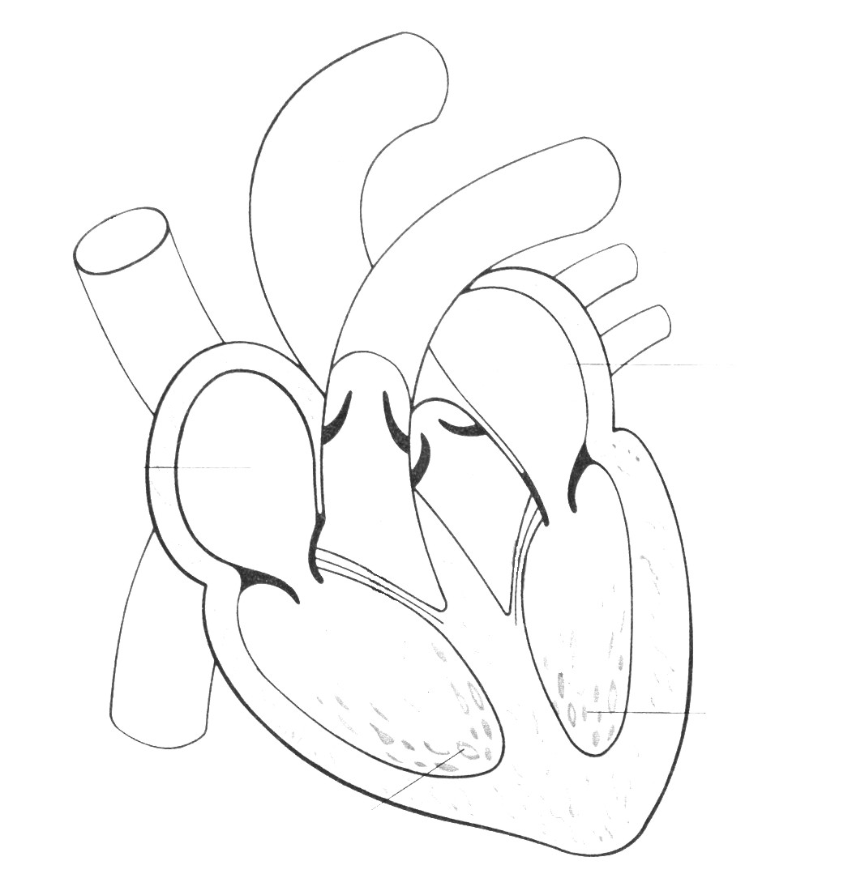
________________________________________________________________________________________________________________________________________________________________________________________________________________________________________________________________________________________________________________________________________________________________________________________________________________________________________________________________________________________________________________________________________________________________________________________________________________________________________________________________________________________________________________________________________________________________________________________________________________________________________________________________________________________________________________________________________________________________________________________________

Spiega come funziona la “pompa cuore” di fianco alle illustrazioni:

________________________________________________________________________________________________________________________________________________________________________________________________________________________________________________________________________________________________________________________________________________________________________________________________________________________________________________________________________________________________________________________________________________________________________________________________________________________________________________________________________________________________________________________________________

______________________________________________________________________________________________________________________________________________________________________________________________________________________________________________________________________________________________________________________________________________________________________________________________________________________________________________________________________________________________________________________________________________________________________________________________________________________________________________________________________________________________________________________________________________________________________________________

Spiega con le tue parole come avviene la circolazione del sangue distinguendo tra piccola e grande circolazione.
__________________________________________________________________________________________________________________________________________________________________________________________________________________________________________________________________________________________________________________________________________________________________________________________________________________________________________________________________________________________________________________________________________________________________________________________________________________________________________________________________________________________________________________________________________________________________________________________________________________________________________________________________________________________________________________________________________________________________________________________________________________________________________________________________________________________________________________________________________________________________________________________________________________________________________________________________________________________

